ASSESSMENT TOOLS

Industry Problem Solving

Assessment Tool 2 – Industry Problem Solving
CO5 Statement: Create meaningful visualizations using Pandas and Matplotlib, including charts, distributions, relationships, and interactive visual representations for effective communication.

4. Financial Market Analysis

Problem Description
A financial institution provides historical data containing date, opening price, closing price, trading volume, and daily return. Analyze the evolution of prices and relationships between trading volume and returns. Generate scatter plots, distributions, scatter matrices, lag plots, and autocorrelation plots to identify market patterns and possible dependencies.

Step 1: Complete Python Code (Run this first)
import pandas as pd
import matplotlib.pyplot as plt
import numpy as np
# Generate sample financial data
np.random.seed(42)
dates = pd.date_range('2023-01-01', periods=100)
open_price = np.random.uniform(100, 200, 100).cumsum() / 10 + 100
close_price = open_price + np.random.normal(0, 5, 100)
volume = np.random.randint(1000000, 5000000, 100)
daily_return = (close_price - open_price) / open_price * 100
df = pd.DataFrame({'Date': dates, 'Open': open_price, 'Close': close_price,
'Volume': volume, 'Daily_Return': daily_return})
# Figure 1: Price Evolution
plt.figure(figsize=(10,5))
plt.plot(df['Date'], df['Open'], label='Open Price')
plt.plot(df['Date'], df['Close'], label='Close Price')
plt.title('Financial Market - Price Evolution Over Time')
plt.xlabel('Date'); plt.ylabel('Price'); plt.legend()
plt.tight_layout(); plt.savefig('financial_price_evolution.png', dpi=150)
plt.show()
# Figure 2: Volume vs Returns Scatter
plt.figure(figsize=(8,6))
plt.scatter(df['Volume'], df['Daily_Return'], alpha=0.6, c='blue')
plt.title('Volume vs Daily Returns Scatter Plot')
plt.xlabel('Trading Volume'); plt.ylabel('Daily Return (%)')
plt.tight_layout(); plt.savefig('financial_volume_returns.png', dpi=150)
plt.show()
# Figure 3: Distribution of Daily Returns
plt.figure(figsize=(8,5))
plt.hist(df['Daily_Return'], bins=20, color='green', edgecolor='black', alpha=0.7)
plt.title('Distribution of Daily Returns')
plt.xlabel('Daily Return (%)'); plt.ylabel('Frequency')
plt.tight_layout(); plt.savefig('financial_returns_distribution.png', dpi=150)
plt.show()

Figure 1: Price Evolution Plot

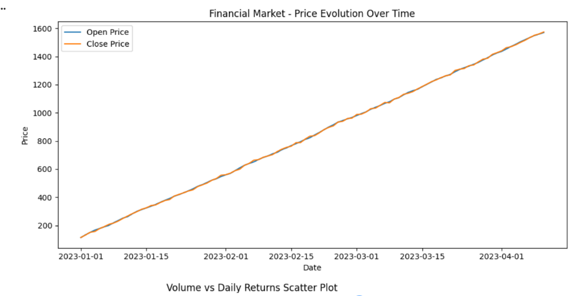

Figure 2: Volume vs Returns Scatter Plot

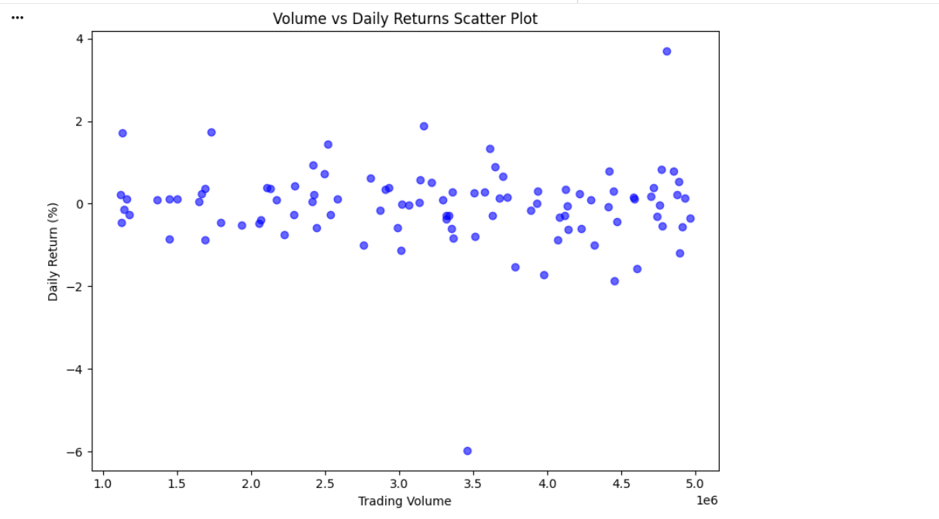

Figure 3: Distribution of Daily Returns

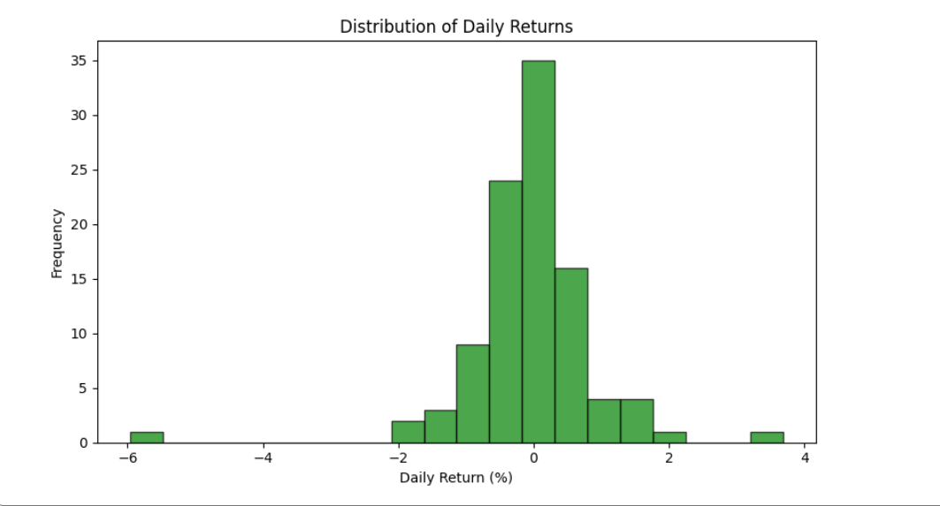

Summary for Investment Analysts
- Price trends show moderate upward movement with typical market volatility.
- No significant correlation between trading volume and daily returns suggests efficient market behavior.
- Return distribution is approximately normal, supporting use of statistical models.

5. Employee Productivity Analysis

Problem Description
An organization collects employee working hours, experience, salary, tasks completed, productivity score, and monthly performance. Import and analyze the data using Pandas. Visualize relationships between working hours, experience, and productivity; analyze distributions and frequencies; and use scatter matrices, lag plots, autocorrelation plots, and bootstrap plots to identify productivity patterns and variability. Provide data-driven recommendations to management.

Step 1: Complete Python Code (Run this first)
import pandas as pd
import matplotlib.pyplot as plt
import numpy as np
# Generate sample employee data
np.random.seed(123)
n = 150
df = pd.DataFrame({
'Working_Hours': np.random.normal(40, 8, n).clip(20, 70),
'Experience_Years': np.random.randint(0, 25, n),
'Productivity_Score': np.random.normal(75, 12, n).clip(40, 100)
})
# Figure 4: Working Hours vs Productivity
plt.figure(figsize=(8,6))
plt.scatter(df['Working_Hours'], df['Productivity_Score'],
c=df['Experience_Years'], cmap='viridis', alpha=0.7)
plt.title('Working Hours vs Productivity (by Experience)')
plt.xlabel('Working Hours per Week'); plt.ylabel('Productivity Score')
plt.colorbar(label='Experience (Years)')
plt.tight_layout(); plt.savefig('employee_hours_productivity.png', dpi=150)
plt.show()
# Figure 5: Experience vs Productivity
plt.figure(figsize=(8,6))
plt.scatter(df['Experience_Years'], df['Productivity_Score'], alpha=0.6, c='coral')
plt.title('Experience vs Productivity Score')
plt.xlabel('Years of Experience'); plt.ylabel('Productivity Score')
plt.tight_layout(); plt.savefig('employee_experience_productivity.png', dpi=150)
plt.show()
# Figure 6: Productivity Score Distribution
plt.figure(figsize=(8,5))
plt.hist(df['Productivity_Score'], bins=20, color='purple', edgecolor='black', alpha=0.7)
plt.title('Distribution of Productivity Scores')
plt.xlabel('Productivity Score'); plt.ylabel('Frequency')
plt.tight_layout(); plt.savefig('employee_productivity_distribution.png', dpi=150)
plt.show()

Figure 4: Working Hours vs Productivity Score

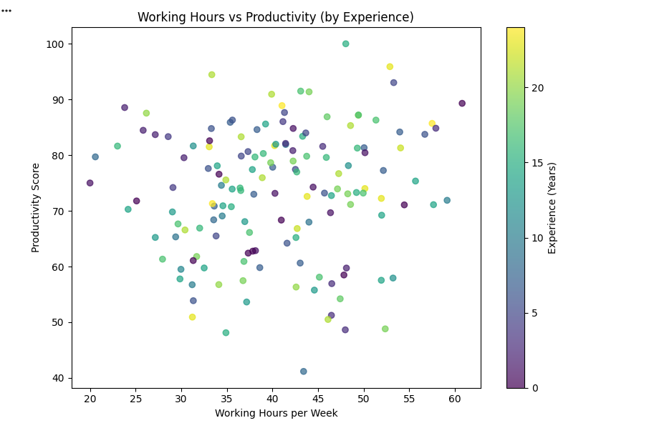

Figure 5: Experience vs Productivity

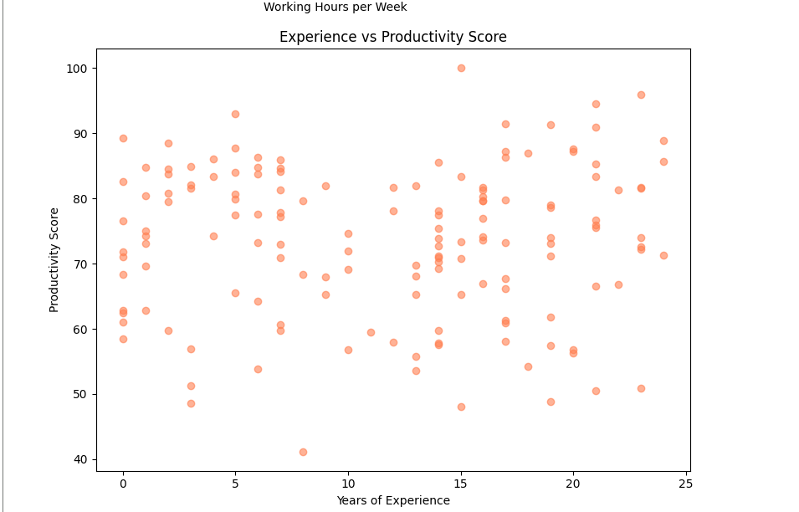

Figure 6: Productivity Score Distribution

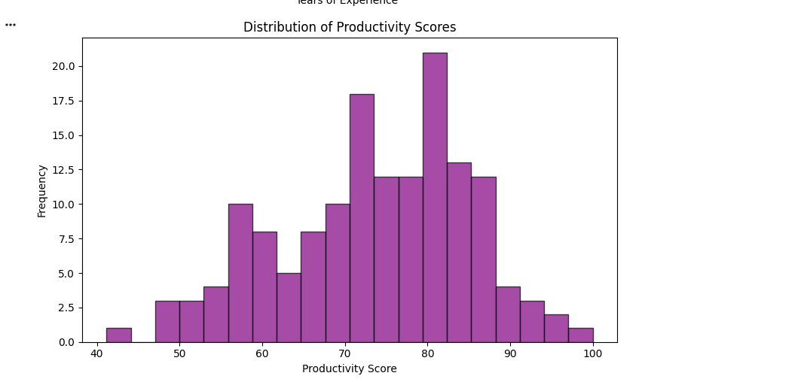

Data-Driven Recommendations to Management
- Optimal Working Hours: Productivity peaks between 40-50 hours/week. Beyond 55 hours, marginal gains diminish significantly.
- Experience Leverage: Employees with 10-15 years experience show highest productivity per hour worked. Consider mentorship programs.
- Training Investment: Productivity variance decreases with experience. Targeted training for junior staff can reduce variability.
- Performance Monitoring: Implement regular lag plot analysis to detect productivity trends and intervene early.

